INTRODUCTION:
A tensile test, also known as tension test, is probably the most fundamental type of mechanical test you can perform on material. Tensile tests are simple, relatively inexpensive, and fully standardised. By pulling on something, you will very quickly determine how the material will react to forces being applied in tension. As the material is being pulled, you will find its strength along with how much it will elongate.
Tensile testing is one of the more basic tests to determine stress – strain relationships. A simple uniaxial test consists of slowly pulling a sample of material in tension until it breaks. Test specimens for tensile testing are generally either circular or rectangular with larger ends to facilitate gripping the sample.
The typical testing procedure is to deform or “stretch” the material at a constant speed. The required load that must be applied to achieve this displacement will vary as the test proceeds. During testing, the stress in the sample can be calculated at any time by dividing the load over the cross-sectional area σ =P/A
The displacement in the sample can be measured at any section where the cross-sectional area is constant and the strain calculated by taking this change in length and dividing it by the original or initial length ε=∆L/L₀
The stress and strain measurements and calculations discussed so far assume a fixed cross sectional area and a change in length that is measured within the constant cross sectional test area of the sample. These stress and strain values are known as engineering stress and engineering strain. The actual stress and strain in the materials for this type of test are higher than the engineering stress and strain; this is obvious when considering that as the tension and elongation increase, the volume of the section of material being tested decreases.
Since it is difficult to measure the actual cross section area during testing to obtain the actual stress values, the testing performed and evaluated in the following experiments will be based on the initial unrestrained geometry of the test sample and calculations will be performed to find the engineering stress and strain rather than the actual stress and strain.
Engineering material properties that can be found from simple tensile testing include the elastic modulus (modulus of elasticity or Young’s modulus), Poisson’s ratio, ultimate tensile strength (tensile strength), yield strength, fracture strength, resilience, toughness, % reduction in area, and % elongations. These values are typically calculated in tension experimentation and compared to published values.
Most of these engineering values are found by graphing the stress and strain values from testing. The modulus of elasticity can be calculated by finding the slope of the stress strain curve where it remains linear and constant. For the materials being tested in this lab, there will be an easily recognizable linear portion of the curve to calculate the elasticity value.
Where the stress strain curve starts to become non linear, this is known as the proportional limit. The proportional limit is also the point where yielding occurs in the material At this point, the material no longer exhibits elastic behavior and permanent deformation occurs. This onset of inelastic behavior is defined as the yield stress or yield strength. Some materials such as the mild steel used in this lab will have a well-defined yield point that can be easily identified on the stress strain curve. Other materials will not have a discernable yield point and other methods must be employed to estimate the yield stress. One common method is the offset method, where a straight line is drawn parallel to the elastic slope and offset an arbitrary amount, most commonly for engineering metals, 0.2%.
The highest stress or load the material is capable of will be the highest measurable stress on the graph. This is termed the ultimate strength or tensile strength. The point at which the material actually fractures is termed the fracture stress. For ductile materials, the Ultimate stress is greater than the fracture stress, but for brittle materials, the ultimate stress is equal the fracture stress.
Ductility is the materials ability to stretch or accommodate inelastic deformation without breaking. Another phenomenon that can be observed of a ductile material undergoing tensile testing is necking. The deformation is initially uniform along the length but tends to concentrate in one region as the testing progresses. This can be observed during testing, the cross sectional area of the highest stress region will visibly reduce.
Two final engineering values that will be determined from the stress strain curve are a measure of energy capacity. The amount of energy the material can absorb while still in the elastic region of the curve is known as the modulus of resilience. The total amount of energy absorbed to the point of fracture is known as the modulus of toughness. These values can be calculated by estimating the respective areas under the stress strain curve. These values are measure of energy capacity, when finding the values under the curve, note that energy is work done per unit volume; therefore the units should be kept in terms of energy, or in-lb per cubic inch.
OBJECTIVE:
To determine the strength and other properties of various materials and other several elastic and plastic properties of various materials.
Or
To develop an understanding of stress-strain curves of materials, and learn how to use them to determine various mechanical properties of ductile and brittle materials.

APPARATUS:
A Universal Testing Machine, Mild steel specimen, vernier calliper/micrometer, dial gauge and graph paper.
THEORY:-
The tensile test is a test performed to know the ductility of the particular material. In practical, the test is carried out on universal testing machine (also called the UTM). When tension is applied to a particular member, the stresses are developed in the member at the centre. At a particular point of time during the testing, the member breaks.
Young’s modulus: Young’s modulus is defined as the ratio of stress to strain. It is denoted by ‘E’.
1. Young's Modulus (Modulus of Elasticity)
In the region on the stress-strain curve where the stress changes linearly with the strain, the Young’s modulus (Modulus of elasticity, E) is defined as the ratio of stress and strain. Value of the Young’s modulus is a constant for a given material.
Tensile stress: Tensile stress is the stress state caused by an applied load that tends to elongate the material in the axis of the applied load, in other words the stress caused by pulling the material. The strength of structures of equal cross sectional area loaded in tension is independent of cross section geometry. Materials loaded in tension are susceptible to stress concentration such as material defects or abrupt changes in the geometry. However, materials exhibiting ductile behaviour (metals for example) can tolerate some defects while brittle materials (such as ceramics) can fail well below their ultimate stress.
Yield strength: Yield strength is the lowest stress that gives permanent deformation in a material. In some materials, like aluminium alloys, the point of yielding is hard to define, thus it is usually given as the stress required causing 0.2% plastic strain. This is called a 0.2% proof stress.
2. Yield point
Yield point is a point on the stress-strain curve, after which there is a significant increase in strain with little or no increase in stress. The corresponding stress is called the Yield Strength of that material. For materials that do not possess well- defined yield point, “offset method” is used to determine it.
Tensile strength: Tensile strength or ultimate tensile strength is a limit state of tensile stress that leads to tensile failure in the manner of ductile failure (yield as the first stage of failure, some hardening in the second stage and break after a possible “neck” formation) or in the manner of brittle failure (sudden breaking in two or more pieces with a low stress state). Tensile strength can be given as either true stress or engineering stress.
Strain: Strain is defined as the ratio of deformed length to the original length.
3. Proportional limit
Proportional limit is the value of stress on the stress-strain curve at which the curve first deviates from a straight line.
4. Elastic Limit
Elastic limit is the value of stress on the stress-strain curve after which the material deforms plastically; that is, it will no longer return to its original size and shape after unloading it.
5. Ultimate tensile strength
Ultimate tensile strength is the highest value of apparent stress on the stress-strain curve.
6. Elastic Deformation
A material under loading is said to have undergone elastic deformation if it reverts back to its original shape and size upon unloading it.
7. Plastic Deformation
A material under loading is said to have undergone plastic deformation if it is permanently deformed upon unloading it.
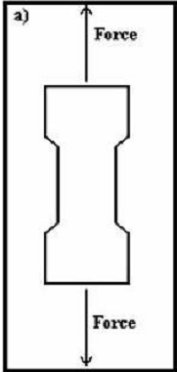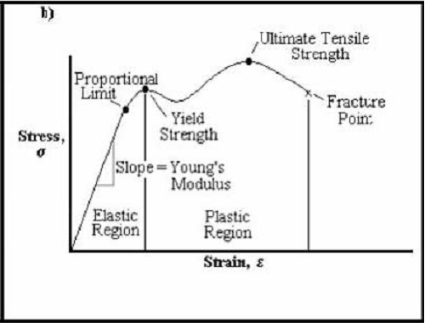
Fig 1: Tensile test specimen Fig 2: A typical stress- strain curve for a ductile material
PROCEDURE:
- The load pointer is set at zero by adjusting the initial the initial setting mode.
- The dial gauge is fixed for measuring elongation of small amounts.
- Measure the diameter of the test piece with the help of a vernier calliper at least at three pieces and determine the mean value. Also mark the gauge length.
- Now the specimen is gripped between the upper and middle cross head jaws of the machine.
- Start the machine and the specimen is gradually loaded. Note down the load and its corresponding dial gauge reading. The observations are taken until the specimen breaks
- Plot the graph between stress vs. strain.
OBSERVATIONS:
1. Initial cross sectional area of specimen, =
2. Initial length of the specimen =
3. Ultimate load after specimen breaks =
4. Final length of the specimen after breaking, =
5. Cross sectional area at the breaking place, =

RESULT:
1. Ultimate tensile strength =
2. Percentage elongation = (( )/
3. Modulus of elasticity =
4. Yield stress =
5. Percentage reduction in area = (()

PRECAUTIONS:
1. The specimen should be prepared in proper dimensions
2. The specimen must be properly placed between the jaws.
3. Take the readings carefully.
4. Stop the machine after the specimen fails.

REFERENCES:
http://www.instron.in/wa/applications/test_types/tension/default.aspx
http://en.wikipedia.org/wiki/Tensile_strength
http://civilx.unm.edu/laboratories_ss/mechmat/tensilesteel.html
“Strength of materials” by Dr. R.K Bansal

QUIZ:
1. Which steel have you tested? What is its carbon content?

2. In what region of a stress vs. strain graph do you find Young’s Modulus?

3. Why do you think we remove the extensometer after yielding occurs?

4. What general information is obtained from the tensile test regarding the properties of the material?

5. Which stress have you calculated: Nominal stress or true stress?

6. What kind of fracture has occurred and why?

7. Which is the most ductile material? What is its elongation?

PART – 2
ANIMATION STEPS
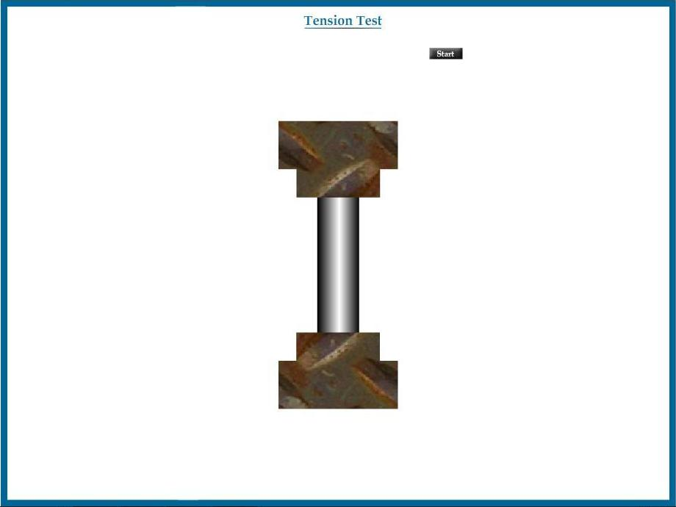

PART – 3
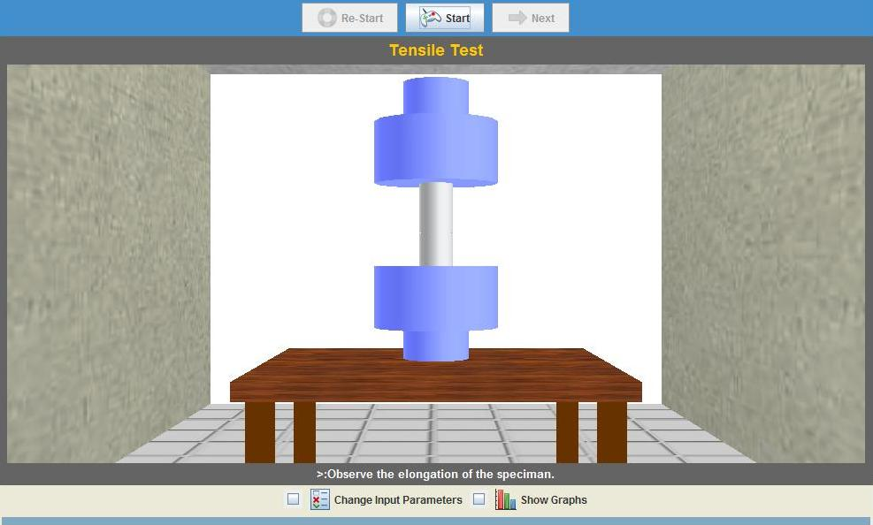
VIRTUAL LAB FRAME

